

**Computer & Electronic Engineering**

**Final Year Project "Music Host Interface"**

**Sprint 4: Week 3 Log**

**Thomas Flynn**

**Project Supervisor: Brian O'Shea**

**25/01/16 - 31/01/16**

# 1 Log Entries

## 1.1.0 Entry 1: 29/01/16

Today I successfully managed to put song files into mySQL database under the field BLOB. I am using mySQL at the moment instead of Microsoft Azure because I want to save money by not paying for the monthly subscription until I need it. I'm hoping the work I do on mySQL can be easily transferred to Azure.

## 1.2.0 Entry 2: 31/01/16

Overall I'm happy with sprint 4. I solved the major issue of "how am I going to play songs from the database? ". The javaFX media player object only accepts file URI's. So to tackle this problem. I have a "temp" folder that all the songs from the DB goes into at run time.

Then my existing code works fine with this as I only had to change the path the temp folder.

# 3 GIT Repositories:

## 3.1 FYP-GUI:

3.1.1 Commit #12"downloading song blobs from mySQL and then playing them".

# 4 Trello boards

## 4.1 Board at the start of the week:

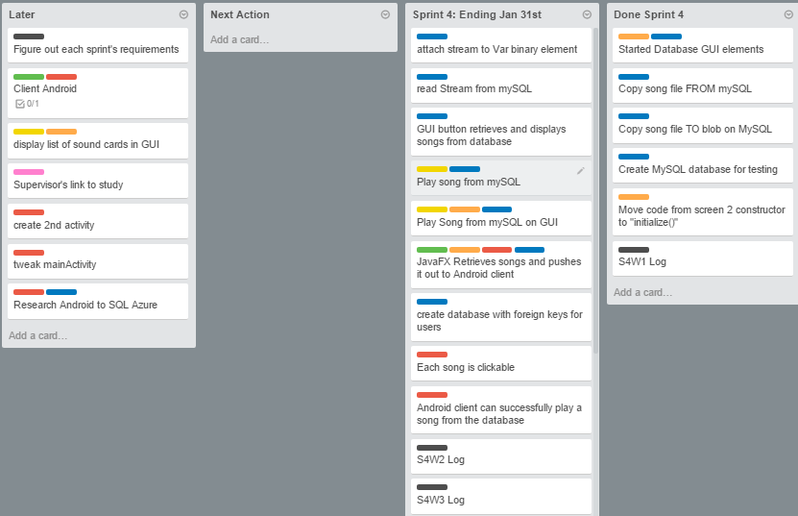

## 4.2 Board at the end of the week:

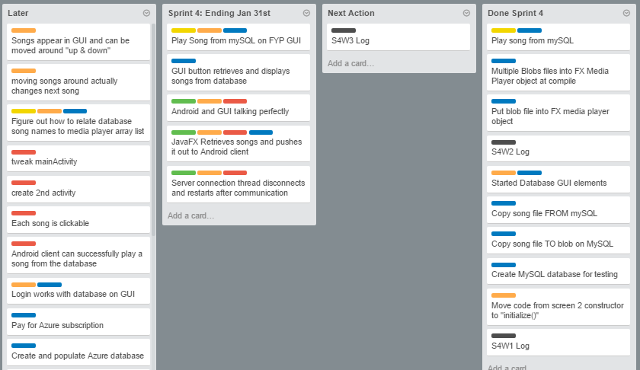

# 5 Toggl Time Logs

## 5.1 Weekly time Log bar chart and pie chart:

